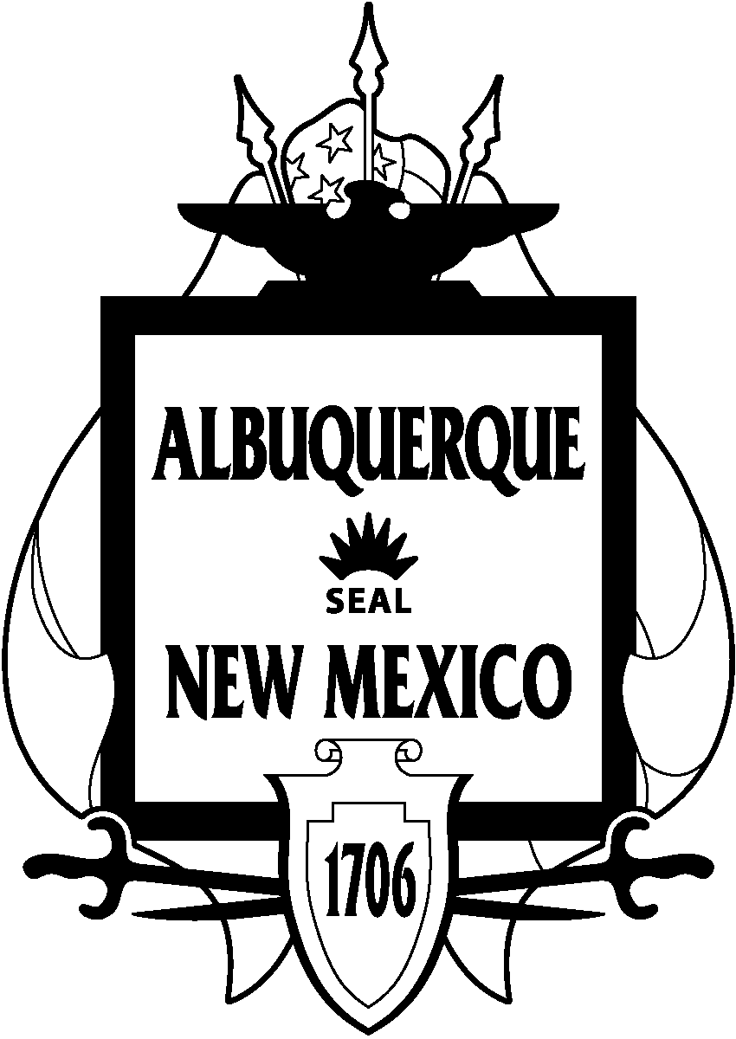
The Council of the
City of Albuquerque
May 3, 2010

WHEREAS, organ and tissue donation are life-giving acts recognized as selfless expressions of compassion to those in need; and

WHEREAS, more than 105,000 men, women and children nationwide including 650 New Mexicans are currently on the national organ transplant list, and every 90 minutes one person dies while waiting for a donated organ; and

WHEREAS, in 2009, 51 New Mexicans donated organs saving the lives of 151 transplant recipients, and 182 New Mexicans donated tissues enhancing the lives of thousands more; and

WHEREAS, over 28,000 lives were saved through organ transplants and one million lives enhanced through tissue transplants in the United States last year; and

WHEREAS, over 950,000 New Mexicans have registered to be donors on the Donate Life Donor Registry on the New Mexico driver’s license or online at NMdonor.org; and

WHEREAS, one individual’s decision to Donate Life can save nine people in need of organ transplants and enhance the lives of up to 50 people in need of tissue transplants; and

BE IT PROCLAIMED THAT THE COUNCIL, THE GOVERNING BODY OF THE CITY OF ALBUQUERQUE, HEREBY RECOGNIZES APRIL 2010 AS “DONATE LIFE MONTH” AND ENCOURAGE EVERY CITIZEN OF ALBUQUERQUE TO SAY “YES!” AND REGISTER TO SAVE LIVES THROUGH ORGAN AND TISSUE DONATION.
Ken Sanchez, President  District 1 | Debbie O’Malley  District 2
Isaac Benton  District 3 | Brad Winter  District 4
Dan Lewis  District 5 | Rey Garduño  District 6
Michael D. Cook  District 7 | Trudy E. Jones, Vice-President  District 8
Don Harris
District 9

